What is it like out there?
Monthly Budget Project
Ms. Vacendak- Learning Strategies
STEP 1: Decide which Scenario is most likely the path you will take… OR want to take.
Scenario 1
You graduated from High School, and received a high school diploma. Jobs you are qualified for are limited, and mostly qualify for jobs that pay minimum wage. Minimum wage is $7.25 an hour. You have been living at home for about a year and have managed saved up about $6,000 cash. Your parents have decided to kick you out of the house. They say its time you learn how to pay bills and besides more importantly they need your room for a home gym.
Scenario 2
You graduated from High School and attended a community college. You received a 2-year degree. You have to stay at home until you get a job. So you have been home with your parents since you started your 2-year degree and now must stay until you save about $6,000.00 cash. You land your dream job making a salary of $28,500 a year. You stay at home for about 6 more months saving and are now ready to move out on your own. How long will you be at home before saving that amount? Also, you have to pay $250.00 per month to pay back the community college.
Scenario 3
You just graduated from College (4 years). It was a great experience you have met a ton of friends living in the dorms and just having a good time. So now you have to begin searching for the job/career you want. According to the graph below how much would your average salary per year be with a bachelor’s degree? You can stop at Bachelor’s degree in this scenario OR you can say you went another 3 years to school to receive a Master’s Degree and/or two more years to receive a Ph. D.
Scenario 4
You are a junior in high school and absolutely do NOT like school and are just ready to get out of this building. So you talk with your parents and decide it’s time to drop out of school. You cannot take any job that will possibly land you in jail in this scenario. You have to get a job where you are able to pay your taxes, which will mean a legit job.
I choose ______________________________________.
Just remember to specify if you are hourly or salary… use the appropriate wording. Salary is different from hourly…

Step 2: Define these words: Gross Pay, Net Pay, Taxes, Wages, Minimum wage, Salary, Gross Salary YTD, pay frequency
Step 3: Pay check calculator: (need this for taxes… this time you will being paying taxes!
Salary calculator: http://www.paycheckcity.com/calculator/salary/
Hourly Calculator: http://www.paycheckcity.com/calculator/hourly/
Salary: http://www.payrollforamerica.com/calculators/North-Carolina-payroll-calculator.php

Requirements to live: Create a table with the following information. I want you to look these costs up and or bring in a part of your parents bill to prove that is the amount you will pay.
- Price of rent for a one or two bedroom apartment.
- Monthly cost of Cable.
- Monthly cost of Power Bill.
- Monthly cost of car insurance.
- The amount you plan to spend on food per month.
- Gas per month. $2.05 per gallon.
- Monthly car payment
- Websites where you FOUND the information.
- Minimum Wage is $7.25 an hour… how many hours do you have to work in order to make the same amount in the career you chose…?
- Savings for emergencies per month?
Directions:
- The amount above is what you are spending per month.
- You will have to subtract your monthly total cost of living from the amount of money you are making per month (if you are salary – that is how much you make per year, so you have to divide that by 12… then put that in the salary calculator to determine NET PAY.
- What is left over is what you have to save or spend, but remember you do not want to live in an apartment forever and you have to save money to eventually buy a home.
- IF you want a pet or have a pet… think vet bills and food costs.
- Do you require a second job to help you with your apartment/ and or housing?

Example IDEA
THIS IN NO WAY THE PROPER AMOUNTS Do NOT USE this Example in your own work.
Angie Vacendak
EC teacher
$1,000 a month
Total | 1,000 | WEBSITE Found
Apartment | -510.00 | apartment.com
Cable | -20.00 | http://www.ehow.com/about_5385381_average-cable-tv-per-month.html
Car insurance | -55.00
Duke Energy | -80.00 | http://www.electricitylocal.com/states/north-carolina/
Grocery | -100.00 | http://www.loweryourspending.com/average-cost-for-food-per-month-for-one-person.html
Car payment | -30.00
Gas | -90.00
Total leftover | $56.00 | Yay big savings !!!!
At 7.25 an hour | ? hours | To make the above total amount. (think taxes too)
Here is a graph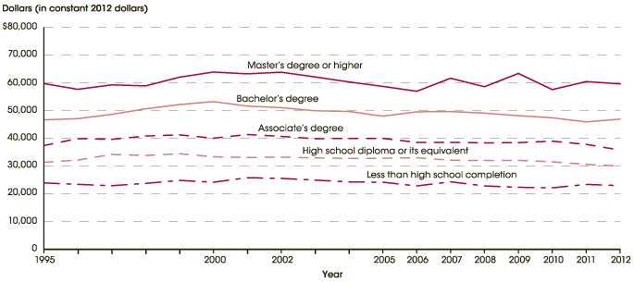

Sites that may help you!
http://www.nationalhighschool.com/graduate_expectations/
http://www.careerbuilder.com/Article/CB-1252-Who-is-Hiring-20-Jobs-You-Can-Get-With-a-High-School-Diploma/
http://jobs.aol.com/articles/2012/08/24/9-good-jobs-for-high-school-dropouts/
http://work.chron.com/careers-available-high-school-diploma-15066.html
http://www.payscale.com/cost-of-living-calculator/North-Carolina-Raleigh
put in your zip code it is 27707, and then click on car payment calculator for website below:
http://www.kbb.com/car-loans-and-financing/?psid=99999&siomid=si4fxbriv_dc|20111905293|calculate%20monthly%20car%20payments|b|6qt283e0x0&gclid=cjwkeaia_4embrcxi8_f2cwwjfcsjab-v1qyiwfvepcw9lemg5f1kna-asrwx7tg5oszmudahj_xbxoc3tpw_wcb&r=490580467041581900
http://www.payscale.com/cost-of-living-calculator/North-Carolina-Raleigh

CONGRATULATIONS YOU ARE OFFICIALLY A GROWN UP!

